**VISVESVARAYA TECHNOLOGICAL UNIVERSITY**



MINI PROJECT REPORT ON

**“BURGLAR ALARM”**

SUBMITTED BY:

**PRASHANTH.B (1NH18EC088)**

**SOUVIK MANNA (1NH18EC)**

**MANISH M (1NH18EC066)**

**YESWANTH(1NH18EC125)**

Under the guidance of

**Ms . ISHANI MISHRA**

Senior Assistatant Professor, Dept. of ECE, NHCE, Bengaluru.

# C:\Documents and Settings\Students\Local Settings\Temporary Internet Files\Content.Word\download (1).jpg

# NEW HORIZON COLLEGE OF ENGINEERING

(ISO-9001:2000 certified, Accredited by NAAC ‘A’, Autonomous college permanently affiliated to VTU)Outer Ring Road, Panathur Post, Near Marathalli, Bengaluru-560103

## NEW HORIZON COLLEGE OF ENGINEERING

## DEPARTMENT OF ELECTRONICS AND COMMUNICATION ENGINEERING



**CERTIFICATE**

Certified that the mini project work entitled “**Burglar Alarm**” carried out by **PRASHANTH.B (1NH18EC088),SOUVIK MANNA (1NH18EC107),MANISH M (1NH18EC066),YESWANTH(1NH18EC125),** bonafide students of Electronics and Communication Department , New Horizon College of Engineering, Bangalore.

The mini project report has been approved as it satisfies the academic requirements in respect of mini project work prescribed for the said degree.

Project Guide HOD ECE

------------------------- -------------------------

**External Viva**

Name of Examiner Signature with Date

1.

2.

**ACKNOWLEDGEMENT**

The satisfaction that accompany the successful completion of any task would be, but impossible without the mention of the people who made it possible, whose constant guidance and encouragement helped us succeed.

We thank **Dr. Mohan Manghnani**, Chairman of **New Horizon Educational Institution**, for providing necessary infrastructure and creating good environment.

We also record here the constant encouragement and facilities extended to us by **Dr.Manjunatha**, Principal, NHCE and **Dr. Sanjeev Sharma**, head of the department of Electronics and Communication Engineering. We extend sincere gratitude to them.

We sincerely acknowledge the encouragement, timely help and guidance to us by our beloved guide **Ms. Ishani Mishra** to complete the project within stipulated time successfully.

Finally, a note of thanks to the teaching and non-teaching staff of electronics and communication department for their co-operation extended to us, who helped us directly or indirectly in this successful completion of mini project.

**PRASHANTH.B (1NH18EC088)**

**SOUVIK MANNA (1NH18EC107)**

**MANISH M (1NH18EC066)**

**YESWANTH(1NH18EC125)**

**TABLE OF CONTENTS**

ABSTRACT

**CHAPTER 1**

INTRODUCTION…………………………………………………………………………………3

**CHAPTER 2**

LITERATURE SURVEY………………………………………………………………………… 4

**CHAPTER 3**

PROPOSED METHODOLOGY…………………………………………………………………..6

**CHAPTER 4**

PROJECT DESCRIPTION ………………………………………………………………………..9

4.1 HARDWARE DESCRIPTION……………………………………………………………….11

4.2 SOFTWARE DESCRIPTION…………………………………………………………………19

**CHAPTER 5**

RESULTS AND DISCUSSION…………………………………………………………………22

**CHAPTER 6**

CONCLUSION AND FUTURE SCOPE …………………………………………………………27

REFERENCES…………………………………………………………………………………….57

APPENDIX………………………………………………………………………………………..58

**LIST OF FIGURES**

|  |  |  |  |
| --- | --- | --- | --- |
| **SL**  **No** | **FIGURE**  **No** | **FIGURE DESCRIPTION** | **Page**  **No** |
| 1 | 1.1 | Block diagram of | 3 |
|  |  |  |  |
|  |  |  |  |
|  |  |  |  |
|  |  |  |  |

### LIST OF TABLES

|  |  |  |  |
| --- | --- | --- | --- |
| **SL**  **No** | **Table**  **No** | **TABLE DESCRIPTION** | **Page**  **No** |
| 1 | 1.1 | Coefficients for analysis and synthesis of filter pairs. | 32 |
|  |  |  |  |

**ABSTRACT**

**CHAPTER 01**

**INTRODUCTION**

Surveillance, from homes to large industries, plays an important role in fulfilling our safety.

Aspects such as burglar and theft have always been a difficult situation. In large industries,

personal security refers to the monitoring of people's changing information, such as activities and

behaviors to protect, manage and influence personal details. Surveillance refers to observation

from a distance through the use of electronic equipment such as CCTV cameras. However,

CCTV technology is expensive for average residents to install. In addition, this type of system

does not immediately notify the user of a theft. This thesis document includes an alarm system to

overcome the deficiencies of regular surveillance systems.

In Kenya, for example, this system may work better due to its lower energy consumption,

especially in remote places where electricity is a challenge. The use of machine-to-machine

communication offers benefits compared to the traditional Data Acquisition System (DAS). The

system allows monitoring and control without human intervention . The system becomes fully

automatic and the amount of error decreases with its efficiency increasing dramatically.

People must have the option of living without fear and the confidence to conduct any business

without fear of insecurity. The system created in this study offers security while maintaining the

privacy of people, since only one person can see it. In addition, it uses a simple circuit. The

system uses Raspbian OS for its operations, which allows the transmission of images to a smart

safe in their daily activities. In addition, it sends an alert signal, which makes it better than the

surveillance systems currently used.

phone . The traditional surveillance system is associated with several challenges and costs

associated with energy use. An energy efficient mobile system is preferable, and can capture

images during a robbery. The system, therefore, allows people to be more independent and feel

The implementation of the project is simple. The owner / company places a camera in a

particular area that needs monitoring to ensure security. The system allows the user to access

and monitor security from different locations, even in remote areas. The user can monitor the

remote surveillance system using a smart phone with internet availability connected. The system

is useful for projects that point to security configurations limited to a specific location, but whose security is monitored from separate locations .Create a security-based system that is more

affordable and flexible in terms of location and the specific objectives are; to. Design a system

based on simple, cost-effective and easy to implement PIR security using existing technology. Design a system based on PIR security for people who wish to control their work, office or home from a distance. To manufacture a system based on PIR security.

The system is small, portable and autonomous, with its power supply that makes it easy to implement. It also has energy for instant alerts and is cost effective for both residential and personal use.

Anti-theft system represents basic infrastructure for alarm management, but set of applications that can implementation can be easy in fact extended the burglar alarm .The system can be used to guarantee protecting people and theirs belonging to dangerous events such as gas leaks, floods etc. from alarm notifications .

Basically in security systems used in homes, shops, offices etc. Infrared or laser transmitters and receivers are used to ensure accuracy and reliability. But these methods require a lot of money investments and infrastructure support.

This project uses a simple, cost-effective solution for security systems, in which I explain the PIR-based alarm system, which uses a PIR sensor instead of a transmitter or receiver. This saves energy consumption and is also an inexpensive solution. The PIR sensor is a short form of passive infrared sensor.

CHAPTER 02

**LITERATURE SURVEY**

**1.Security cameras**

Security cameras are of many types with seemingly many feature preferences . Say using the camera to use in a home can be a daunting task given the number of options although these cameras are available in a wide range of sizes , the fields of view image quality and different ranges of motion , security cameras used in all homes provide video images of events within a filed of vision. The cameras can show the actions that take place in real time or record everything for later viewing. Some of camera systems allow users to observe and control their security cameras online. Security cameras are classified into those used indoor and outdoors. Each of the categories have different camera styles. Additional differentiation, in general is not necessary. Because the variation is evident during the evaluation of characteristics. Security cameras can come as independent units with applications installed to monitor system or as part of a package to which users subscribe to provide home security.

**1.1 Indoor home security cameras**

Cameras which are used in indoor settings are the foundation for home security system .

The following table has types of indoor cameras and corresponding resolution , advantages and disadvantages.

|  |  |  |  |
| --- | --- | --- | --- |
| Camera type | Resolution | Advantages | Dis -  -advantages |
| Vimtag VT-361 PTZ cloud camera | 720p | * it has 120 pan and can tilt at 320 * it possesses a mic and a speaker to enable 2-way talkback * affordable cost | * the static field of view is not known |
| Nest cam indoor | 1080p | * the camera has a good resolution for clarity of images * it has a mic and speaker to enable the 2-way talkback * huge field of view 130 degree | * the camera is costly * the night-vision distance of the camera is unknown * no movement |
| Arlo wire – free VMS 3130 | 720p | * ability to be used outdoors * it has a night vision range of 25 feet * its field of view is at 110 degree , enabling a wider view | * no sound capabilities * high prices |
| Amcrest | 1080p | * the camera type has an improved night vision in the range of 32 feet * it has a speaker and a mic to enable the 2-way talkback | * the camera is costly to the user |

**1.2 Outdoor home security cameras**

Outdoor security cameras are called multi-camera surveillance systems. They monitor any outdoor area of ​​your choice and are available as wired or wireless. Typical locations include gateways, entrances and vehicle entrances. Outdoor cameras are purposely designed with a wider viewing angle to monitor large outdoor areas. Most of these devices come with night vision to capture videos and images during the dark. The cameras are designed to be weatherproof with a durable protective housing to protect the electronics from moisture and rain.

The following table has outdoor cameras and its resolution,advantages,disadvantages.

|  |  |  |  |
| --- | --- | --- | --- |
| camera type | resolution | pros | cons |
| Amcrest Qcam | 1536p | * good night vision range of 65 feet * great resolution | * no movement capability * no Wi-Fi capability * no sound capabilities |
| ZOSI 960H | 900 tvl | * low price * good field of vision at 72 degree * great range of night vision at 20 feet | * has no movement capability * does not have Wi-Fi * no sound capabilities |
| Uniden GC45S | 1080p | * has mic and a speaker for 2-way talkback * pan and tilt capabilities * good resolution | * requires purchase of full system * has a low night vision has the range of 40 feet |
| Phylink bullet HD | 1080p | * great field of vision of 90 degree * built-in mic * good resolution | * no zoom * high price * low night vision of 30 degree feet |

2.2 sensors

A sensor is an electronic device that detects and responds to an optical or electrical system.

signal. The sensors convert the input of physical parameters, e.g. humidity, temperature,

light, heat, movement and other environmental phenomena measured at an electrical signal. The electrical signal becomes a human readable interface and is displayed in

computer monitors for reading, interpretation and processing .

The sensors provide complete protection for the entire house. The improvement of technology with respect to modern security has allowed users of security systems to monitor and view

alerts through your smartphones when the sensors are activated. Technology has increased the

effectiveness of security systems and reduction of time needed in response to security breaches. Common safety sensors used include environmental sensors,

smoke detectors, broken glass, door / window sensors that have been useful to improve the effectiveness of the security system.

2.2.1 Glass break detectors / sensors

The glass break sensor is used in electronic burglar alarms and detects if a piece of glass

It is broken or broken. The sensor works by monitoring vibration and sound, thus complementing the door / window sensors. When the glass breaks; The sensor detects the frequency or shock waves and sounds an alarm. Glass break detectors remain armed to

all the time and improve the efficiency of security systems.

Glass sensors are ideal for rooms with sliding doors and large windows. The limited range associated with detectors requires an owner to repair multiple glass break sensors to improve efficiency. Figure below shows glass break detectors.

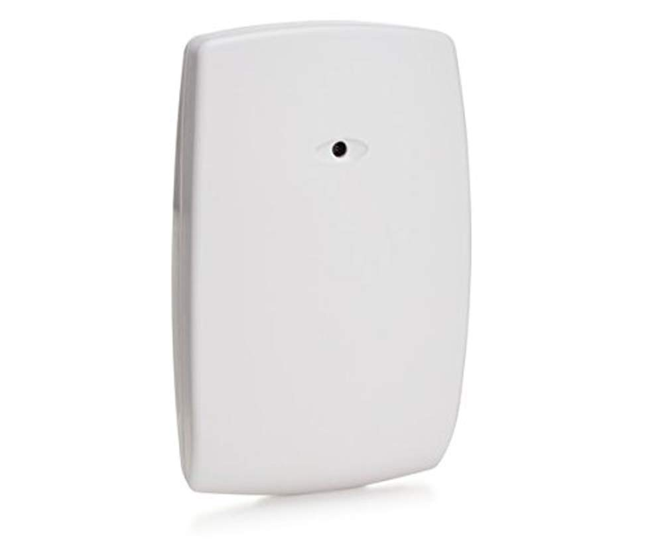

* There are two types of glass break sensors, acoustic and shock sensors. Acoustic sensors are designed to detect the exact sound waves of broken glass while

Shock sensors detect vibrations when the glass breaks. The shock sensors are likely to

activate false alarms as a result of slamming doors that could have vibrations similar to

break the glass To overcome these limitations, an owner must opt ​​for glass breakage

detectors that depend on acoustic sensors equipped with small microphones

of detecting specific frequencies associated with breaking a glass

2.2.2 .Window and door sensors Home security systems are guaranteed by the defense used in secure windows and Doors Most of the thefts reported annually are a robbery in residential homes as a result of entry through doors and windows. The security of a home is guaranteed by installation Door and window sensors to prevent entry and potential danger. These sensors are placed in the doors and windows of the buildings. When the door or the window is broken, the sensor transmits a signal to the central control system that triggers an alarm. Window or door sensors are easy to configure since no wiring is required. Its operating range is up to 150 feet from the Choice Alert Wireless Control Center and has a durable and weatherproof design.

Next, in Figure given below, there are some images of window and door sensors

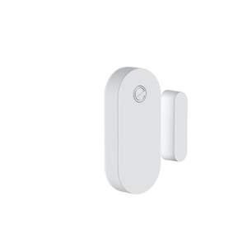

The window / door sensors come in two. One fits in the door / window while the other is

glued to the frame and held in place by adhesives or screwed to the door or window frame. The two pieces of sensors are placed close to each other so that when they are

separated, for example through the opening of the door, activates an alarm.

2.2.3 Smoke detectors

Smoke detectors are devices that detect smoke, a common fire indicator. These devices detect the combustion of gases such as carbon dioxide and carbon monoxide. Smoke

home detectors, also called smoke detectors, emit a visual or audible alarm

. They reduce the risks associated with death in a home fire.

Figure below illustrates the designs of smoke detectors .

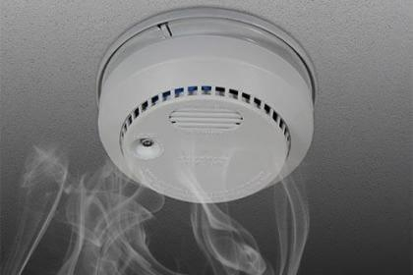

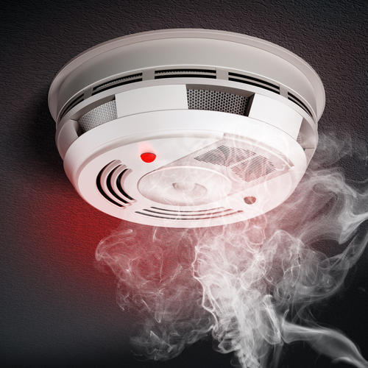

The detectors are housed in disc-shaped plastic enclosures. They allow the detection of

smoking through ionization or optically.

2.2.4 Motion sensors

Motion sensors use infrared sound and vibration to detect moving objects or people.

The sensors collect data regarding the acceleration, speed and position of the object. When motion sensors are connected to a home security system, they can detect

movement alerting the owner of any security breach.

Motion sensors use one or more technologies to detect movement in an area. the

use of multiple technologies, microwave technology and passive infrared sensor (PIR)

technology, helps reduce the possibility of false alarms and increases the efficiency of

The security surveillance system. The sensors are sensitive to the temperature of an individual's skin and are designed to use medium infrared wavelengths in motion detection.

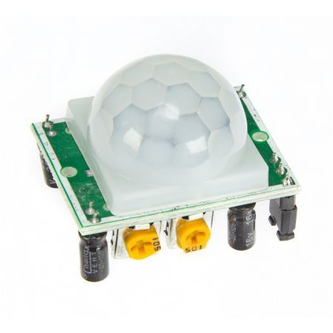

**CHAPTER 03**

**PROPOSED METHODOLOGY**

The burglar alarm system is a part of home security systems. This burglar alarm project is based on the PIR sensor, UM3561 and the speaker. PIR sensor used to detect body movement and UM3561 and speaker to produce the police siren after any motion detection.

### **Required Components**

### **🡪** PIR sensor

**🡪 UM3561 IC**

**🡪 Resistors 220K and 10K**

**🡪 Transistor BC547**

**🡪 Speaker 8ohm**

**🡪 Battery 9v**

**PIR sensor**

The PIR sensor is used here to detect the movement of the human body, every time there is any movement of the body, the voltage at the output pin changes. Basically, it detects the change in heat and produces output every time that detection occurs. You can get more information about the PIR sensor in this PIR sensor circuit, there are some useful features in the PIR sensor such as how to change the distance range, how to set the alarm duration, etc.

The main idea of ​​the circuit is to ensure safety. It's based on a PIR sensor with an integrated circuit that produces a siren. The PIR sensor detects the IR radiation emitted by people and produces a digital signal. Based on the digital signal from the PIR sensor, Arduino UNO then starts the UM 3561 siren system. In this way it generates sound when it detects any human being.UM3561 is ROM IC.

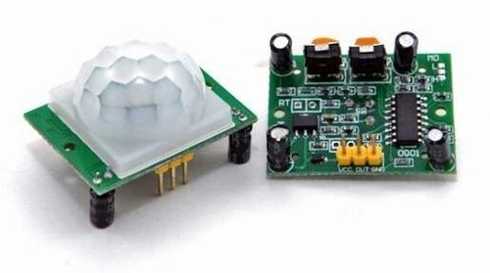

**UM3561 IC**

IC UM3561 is a LSI CMOS IC that can generate four types of sound: police siren, ambulance siren, fire siren and machine gun sound. It is generally used in alarms and toys. It is an 8-pin IC, and only requires an external resistor to function. It has built-in oscillators and circuits to produce the sounds. UM3561 operates in the 3-5 volt range, a voltage greater than 5V can damage the IC, so if we are using it with another circuit or with a high voltage source, a Zener diode must be connected to protect the IC. The output generated by the IC is not sufficient to control a small 8ohm speaker, so to amplify the output of the IC, a transistor must be used at the output (PIN 3).

The pin diagram and the description of the pin are given below, taken from its data sheet:

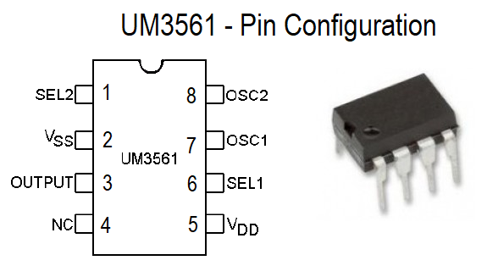

Zener diodes are like the other diodes, with only one difference. All diodes allow current flow in only one direction (forward), but the Zener diode can allow current in the reverse direction if the voltage exceeds a certain limit. This voltage is called the breakdown voltage or Zener knee voltage. Therefore, this property of the Zener diode protects the UM3561 IC by avoiding a higher voltage supply.

**Resistors 220K and 10K**

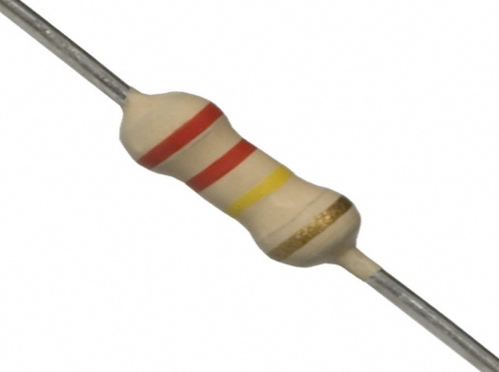

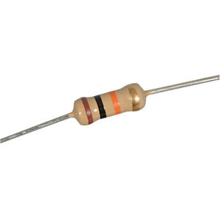

**220k ohm 10k ohm**

**Transistor BC547**

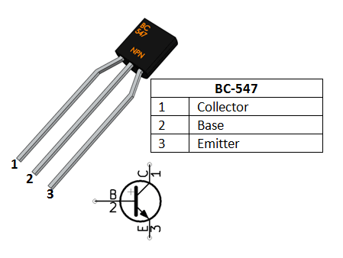

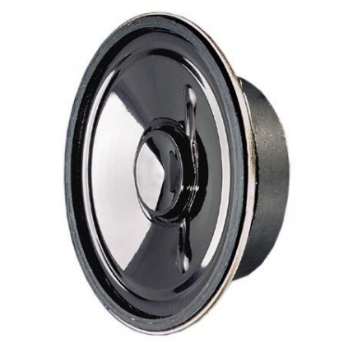 **Speaker 8ohm**

**Battery 9v**



**CHAPTER 04**

**PROJECT DESCRIPTION**

**Safety alarm circuit design based on PIR sensor:**

The proposed system consists mainly of PIR sensor, UM3561 IC, speaker, transistors. the

UM3516 IC is a siren generator IC. It has 8 pins. The fifth and sixth pins are short and are

connected to the output of the PIR sensor through a resistor. An end of 220K resistance is

connected to the seventh pin of the IC and the other end is connected to the eighth pin of the

IC. The first pin and the sixth pin are tone selection pins and these pins decide that the tone be

produced. The output is taken from the third pin of the IC. It is connected to a speaker through a

resistance and transistor. The base of the transistor is connected to the output of the IC through a

470 ohm resistance. The transmitter pin is grounded while the transistor is connected to

the collector. A battery is connected to the speaker and the 470 ohm resistor.

Operation of the alarm system based on the PIR sensor

Make connections according to the wiring diagram and turn on the circuit.

The PIR sensor is powered and detects IR rays emitted by every human being.

This PIR sensor has a range of 5 meters. You can adjust the potentiometer provided for the sensor to change the distance.

When any person is detected, the PIR sensor is HIGH . During this time, Siren IC UM3561 is activated because its contact 5 is powered + 5 V.The siren generator has an internal oscillator that produces sound.The oscillator circuit is tuned to a specific frequency and using an external 220 kΩ resistor.Then it is passed to the control circuit, which depends on the tone selection pins.These tone selection contacts determine one tone from different tones produced by the integrated circuit.In this way, the oscillations along with the selected tone are sent to the address counter. The address counter then sends the data to ROM.The ROM then sends tone at output 3.

The output is fed to the NPN transistor to amplify the siren.The transistor base draws the voltage from the siren generator output contact.The transistor begins to conduct when it receives the cut-off voltage at the base, and the speaker is a negative contact and is connected to the ground.In this way, the sound produced can be heard from the speaker when a person is detected.Generates a police siren in the current circuit . Adjust the PIR sensor potentiometer to detect only people.

Circuit diagram 
 

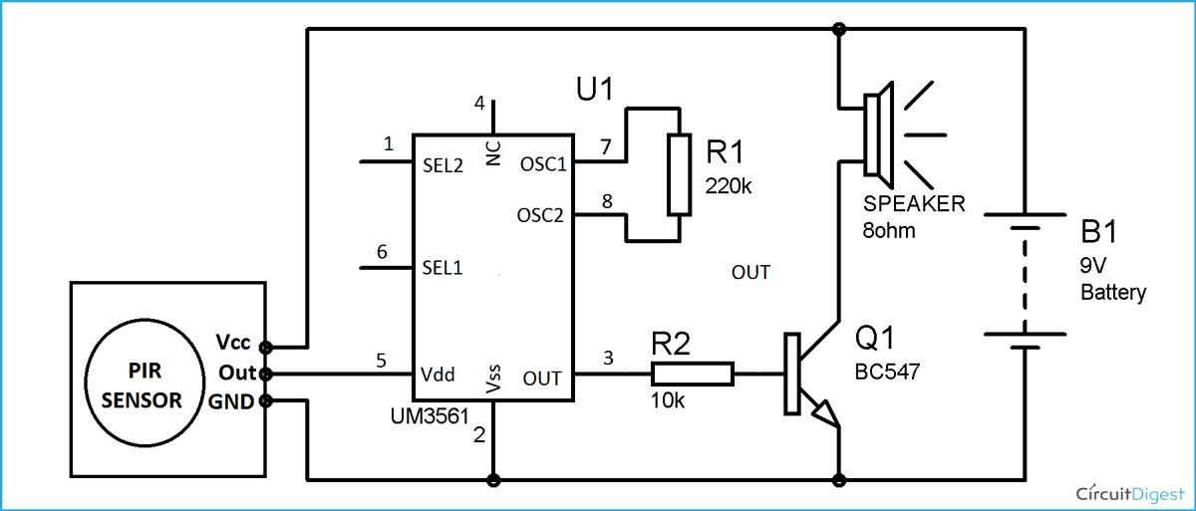

**CHAPTER 05**

**RESULT AND DISCUSSION**

**Operation of the security alarm system based on PIR sensor**

We turned on the circuit initially. The PIR sensor became activated. It starts to detect the IR rays comes from human beings. The PIR sensor has a limited capacity to capture the IR rays which are emitted from human beings. It seems 5 meters. But the range is possible to control by using a pot. If a human being is detected by the PIR sensor, it catches the IR rays and starts to produce a high logical value (nearly 3.5 volt to 5 volt). In the system there has a IC(Um3561).It works as an oscillator. The voltage produced by the sensor is given as a input to the IC. The IC produces the sound. The IC is a siren generator. The oscillator circuit is tuned to a certain frequency. A 220K resistor is uses externally. After that it is ready to control circuit. That is depending on the tone selection pins, which selects any of the tones produced by the IC. Now oscillations are sent to the address counter with the selected tone. The data is sent to ROM by the counter. Now the input of the ROM is sent to the output pin 3. Now the output goes to the NPN transistor. It amplifies the sound. The base of the transistor is connected to the output pin of the generator.

It receives voltage from the output pin of the generator. The transistor starts driving as soon as it gets the cut-off voltage at the base. The speaker is Negative pin. It is grounded. Now the sound produced by the speaker can be heard. In our circuit it can produce two type of sound. These sounds are ambulance sound and sound of a siren.

**DISCUSSION**

This burglar alarm circuit is very simple,every time the PIR sensor detects any movement of the human body, its OUTPUT pin becomes HIGH, which is connected to PIN 5 of the UM3561 power supply. Then the UM3561 is activated and starts producing sound with the speaker. As I said earlier, UM3561 does not produce much output to drive a speaker, Therefore, it is necessary to amplify the current by connecting a transistor. While the PIR sensor's OUTPUT pin is HIGH, an alarm (speaker) sounds continuously and UM3561 sounds. You can set the alarm time period by configuring the PIR sensor time delay control regulator. You can set the required time. In this circuit, the UM3561 is connected to the PIR sensor output in this circuit, and since the PIR sensor is approximately 13.3v is in the operating voltage range of the UM3561, no protection against high voltage is required. However, it can be used for preventive purpose.

**CHAPTER 06**

**CONCLUSION AND FUTURE SCOPE**

The article presents one of the simplest and most effective. ways to save energy automatically in any room of any building or organization. This was accomplished by the ATMEGA8 and passive microcontroller application Infrared sensor as the main building blocks. Random test selected for a duration of 3 hours using the module showed a 15% saving in energy consumption and the translation to the number of active working hours of type of lighting used. This is based on the premise that the Manual control switches operate with 50% accuracy. In this security system based on PIR sensors, we has used a low-cost and low-cost PIR sensor that is easy to use Interface with other components. By using this system we they were able to reduce the energy consumed and memory system space. Currently, we have only used one webcam in our project that could only capture the area in front of it. The system may not work if intruders enter on the other side The software developed for recording. the video captured by the webcam is only experienced with a webcam connected to the system there was also Some delay in recording video captured by the webcam. Taking into account all the previous points, the following are our future Work established to improve the system: is a electronic components that interconnect two separate electrical circuits by means of light sensitive optics Interface. It is a six-pin device.

1. Work to reduce human efforts.

2. To save electricity from waste.

3. To improve the security system.

4. Work to reduce the delay time in recording.

5. Video captured by the webcam. Use more than one webcam and integrate these webcams with the system.

6. Work on the software to record many videos

**REFERENCES**

[1] L. Herbert, Berman, Altos Hills Los , and Calif, "Infrared Intrusion Detector System," 3,703,718, Nov. 21, 1972.

[2] S. Yuvaraj Prof. and Ramesh S., "Improved Response Time on Safety Mechansim Based on PIR sensor," International Journal of Emerging Technology and Advanced Engineering, vol. 2, no. 4, April 2012.

[3] Anonymus (2007, March 13), “The Electromagnetic Spectrum” [online] <http://science.hq.nasa.gov/kids/imagers/ems/infrared.html>.

[4] Zamshed Iqbal Chowdhury, Haider Masudul Imtiaz, Moinul Muhammad Azam, Aktar Mst. Rumana Sumi, and Nafisa Shahera Nur, "Design and Implementation of Pyroelectric Infrared Sensor Based Security System Using Microcontroller," in Proceeding of the 2011 IEEE Students' Technology Symposium 14-16 January, 2011, lIT Kharagpur, 2013.

[5] Piero Zappi, Elisabetta Farella, and Luca Benini, "Tracking motion direction and distance with Pyroelectric InfraRed Sensors," IEEE Sensor Journal Class Files, 2008

**APPENDIX**

https://www.alldatasheet.net/datasheet-pdf/pdf/255759/BOWIN/UM3561.html